Fish for the Future: How the World’s Seafood Supply Is Changing
For thousands of years, humanity turned to rivers, lakes, and oceans as if they were an endless pantry. Fish and seafood seemed infinite - a gift of nature that would always replenish itself. But the data tell us a different story. By the 1990s, global wild-caught fisheries reached their ceiling. The oceans had given all they could. Since then, the world has increasingly turned to aquaculture - the farming of fish, shellfish, and seaweed to fill the gap and feed a growing population.
What emerges from the numbers is not a tale of boundless abundance, but one of limits, adaptation, and fragile hope.
A Crossing of the Curves
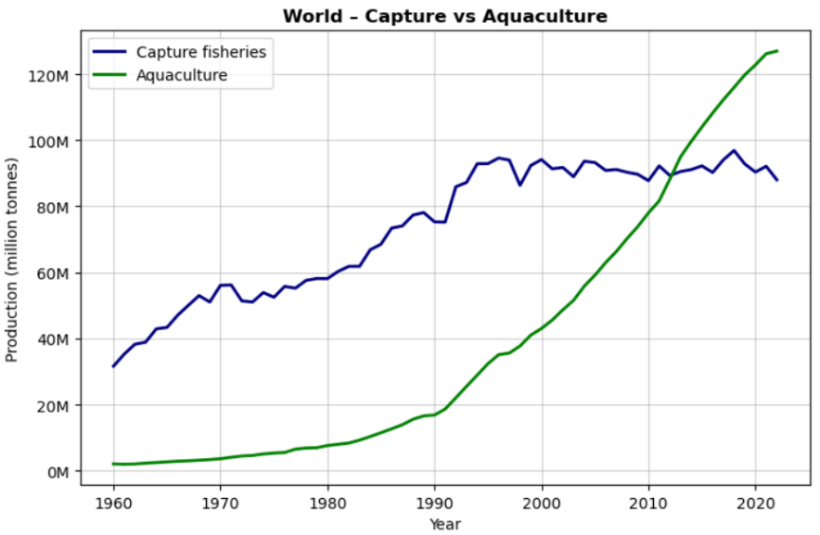
At the global level, two lines tell the story.
- Capture fisheries surged from around 30 million tonnes in 1960 to nearly 95 million tonnes by the 1990s. But since then, growth has stalled. For more than three decades, catches have fluctuated between 85 to 95 million tonnes, never breaking through that ecological ceiling.
- Aquaculture, on the other hand, barely registered in 1960. By the 1980s it was still small, but from the 1990s onward it exploded. By 2000, farmed fish reached 35 million tonnes. By 2010 it had doubled to over 60 million tonnes. And by 2022, aquaculture soared past 120 million tonnes, surpassing wild catch for the first time in history.
This is more than just a data point. It is a turning point in humanity’s relationship with nature: for the first time, we farm more fish than we catch from the wild.
Geography: Where the Fish Come From
Breaking the numbers down by region reveals different stories.
Capture fisheries
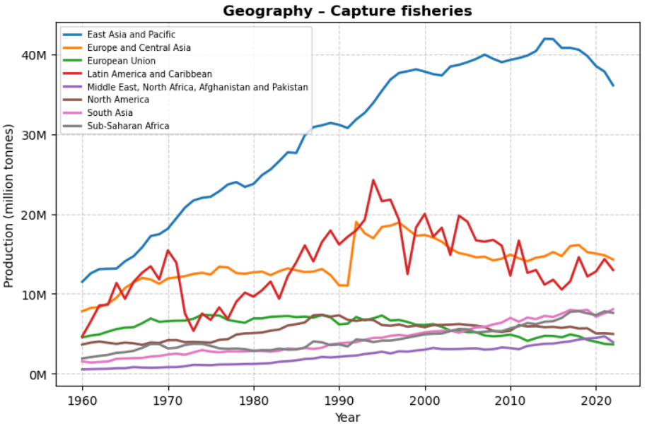
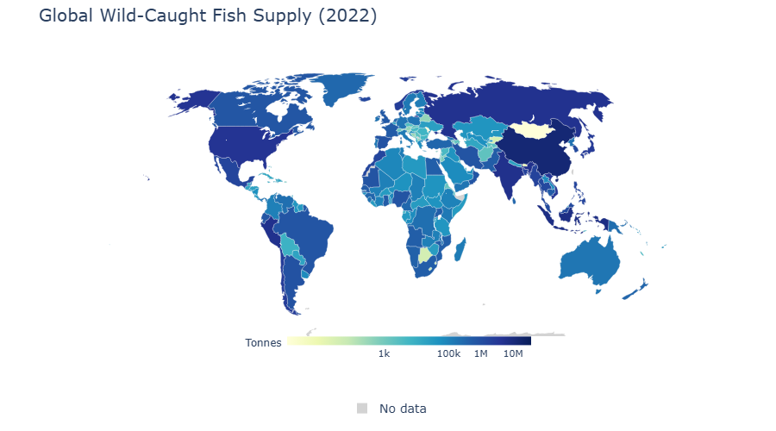
- East Asia and Pacific has been the powerhouse, producing over 40 million tonnes at its peak, though recent years show a slight decline to about 37 million tonnes.
- Europe and Central Asia and Latin America and the Caribbean both hover between 10 to 20 million tonnes, but both have seen declines since the 1990s.
- North America and South Asia each contribute around 5 to 10 million tonnes, relatively stable over time.
- Sub-Saharan Africa has grown slowly but steadily, though it remains under 10 million tonnes.
Aquaculture
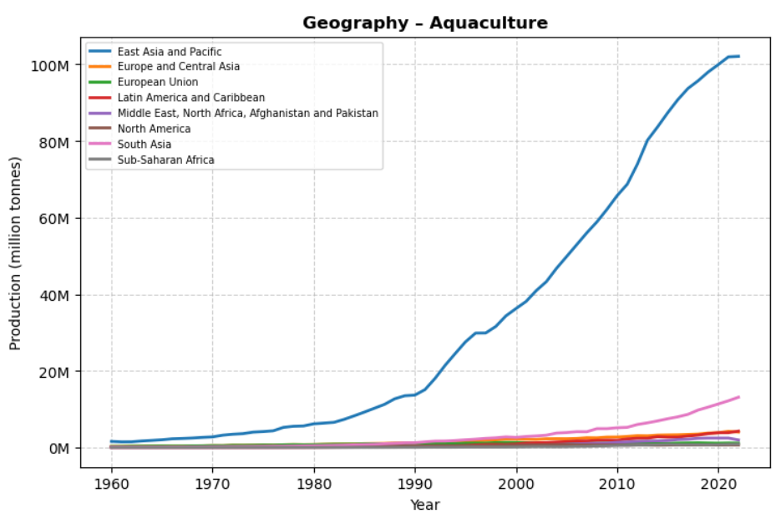
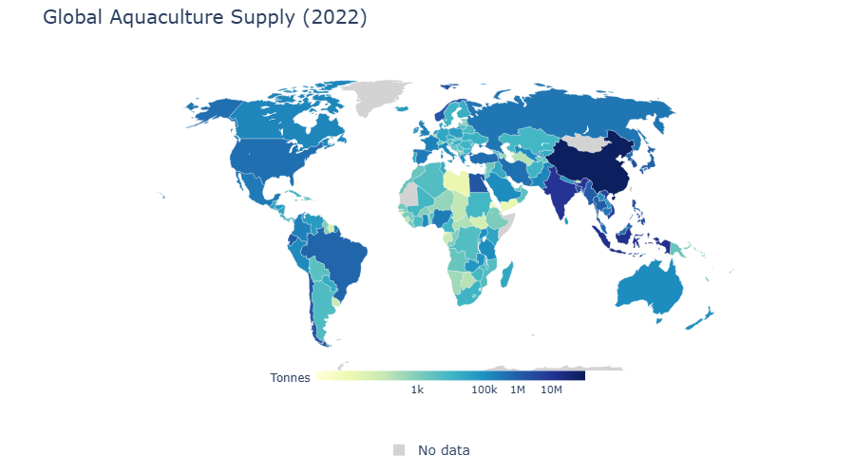
The aquaculture map looks very different.
- East Asia and Pacific, led by China, utterly dominates, producing more than 100 million tonnes by 2022.
- South Asia, with countries like India and Bangladesh, has grown rapidly, now producing over 10 million tonnes.
- Other regions - Europe, Latin America, Africa, North America produce only a fraction, typically in the low single-digit millions.
The 2022 maps make this vivid. China alone produces around 70 million tonnes of farmed fish, dwarfing all other nations. India adds nearly 9 million tonnes, Indonesia about 6 million, and Vietnam around 4 million. Meanwhile, Peru, Russia, and the United States still stand out in the wild-caught category.
Income Groups: Who Farms, Who Catches
When viewed by income level, the patterns shift again.
- High-income countries: Capture fisheries dominate, with 30 to 40 million tonnes annually. Aquaculture exists but is modest.
- Upper-middle-income countries: The heart of the aquaculture boom. By 2022, they produced 80+ million tonnes of farmed fish, far outstripping their capture output of nearly 30 million tonnes.
- Lower-middle-income countries: Both capture (25 million tonnes) and aquaculture (20 to 25 million tonnes) are rising, with aquaculture closing the gap.
- Low-income countries: Production is small overall, under 5 million tonnes for both capture and aquaculture, but aquaculture growth is beginning to take hold.
This split shows a structural shift: wealthier countries continue to rely more on wild catch, while middle-income nations, especially in Asia, have embraced fish farming as the new frontier.
What It Means for Nature
The numbers are not just about food supply. They are about ecological pressure.
- The oceans have reached their limit. Wild catches at 90 million tonnes represent a ceiling - nature’s hard boundary. Aquaculture has stepped in to meet rising demand.
- This gives the seas breathing space. Without aquaculture, pressure on wild stocks would have pushed many ecosystems into collapse.
- But farming comes with costs. Nutrient pollution, habitat loss, and reliance on fishmeal from smaller wild fish create new ecological pressures. The challenge has shifted from open seas to coasts, rivers, and farms.
- Not all aquaculture is harmful. Shellfish and seaweed farming improve water quality and capture carbon. Integrated systems recycle waste and reduce impacts. These models show that farming can be a partner to ecosystems, not just a burden.
A Second Chance for the Seas
The data tell us this: nature has drawn its line. Wild-caught fisheries can no longer grow. Aquaculture has risen spectacularly to feed the world, producing more than 120 million tonnes by 2022. For the oceans, this is a reprieve - a second chance.
But whether this story becomes one of hope or strain depends on choices we make now. Will aquaculture evolve into a sustainable ally of nature, or will it simply shift the crisis from the seas to our coasts and rivers?
The numbers remind us of both possibility and risk. For the first time in history, humanity’s future fish supply is in our hands, literally farmed by us. Whether that becomes a gift to the planet or another test of its resilience is the question that lies ahead.

